Number is a data type in java script

if we do typeof(10) // it tells us Number

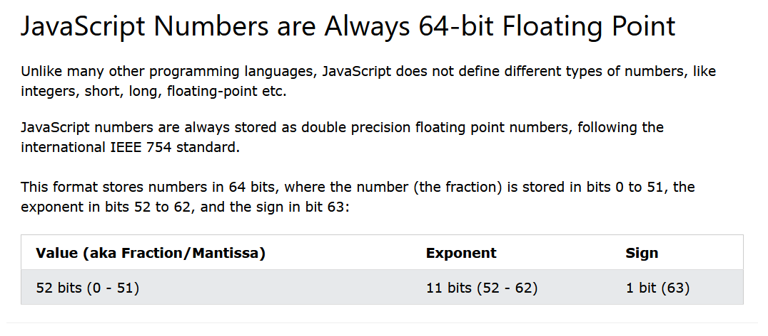

**Conversion of a Number to String**

.toString()

